Detecting and Counting Objects with Circular Features

[Elad Eizner](http://imageprocessingblog.com/author/elad-eizner/)       July 3, 2013      [Image Segmentation & Object Recognition](http://imageprocessingblog.com/category/image-segmentation-object-recognition/), [Recent Posts](http://imageprocessingblog.com/category/recent-posts/)     [3 Comments](http://imageprocessingblog.com/detecting-and-counting-objects-with-circular-features/#comments)

This example shows how you can use*imfindcircles* together with *removeoverlap*function (can be found in the [file exchange](http://www.mathworks.com/matlabcentral/fileexchange/42370)), for counting fungi spores, which has various elliptical like shapes.

imshow(image);

[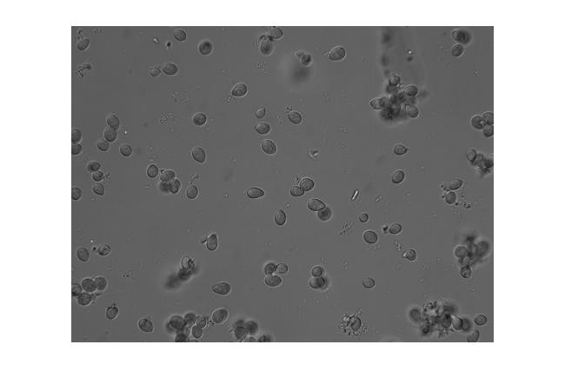](http://imageprocessingblog.com/wp-content/uploads/2013/07/Spores4.jpg)

As you can see, the spores have different shapes and sizes, some overlap objects from other planes of the imaged sample. This is a common microscopy problem in biology.

First, try to find circles in the image using *imfindcircles. For estimating the radius range of our objects we can use imdisline:*

l= imdistline;

Using a radius range between 12 to 30 pixel and visualizing the results with *viscircles:*

[centers, radii] = imfindcircles(image,[12 30]);  
close all;figure; imshow(image);  
viscircles(centers, radii,'EdgeColor','b');

[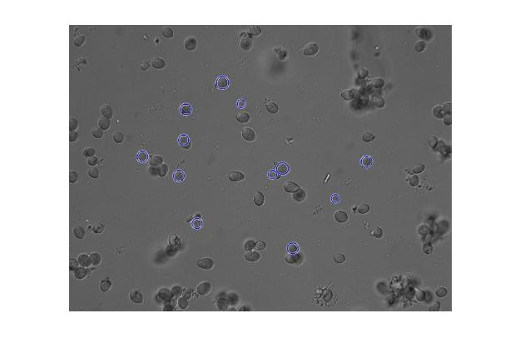](http://imageprocessingblog.com/wp-content/uploads/2013/07/Spores111.jpg)

Lets increase the Sensitivity factor (the default is 0.85) and use a low static Edge Gradient Threshold instead of the default graytreshold.

[centers, radii] = imfindcircles(image,[12 30],'Sensitivity',0.92,'Edge',0.03);  
close all;figure; imshow(image);  
viscircles(centers, radii,'EdgeColor','b');

[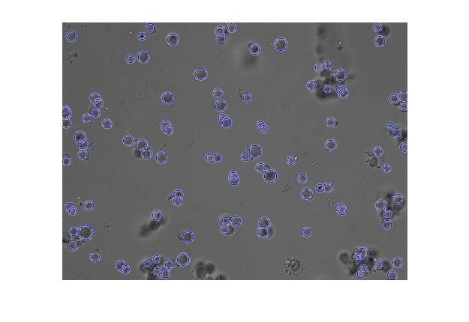](http://imageprocessingblog.com/wp-content/uploads/2013/07/Spores211.jpg)

Now, it seems we detected more circles than spores, mostly because of overlapping circles. Using *removeoverlap*function we can remove the overlapping circles, or allow an overlap of circle pair up to some tolerance, e.g: 5 pixels overlap.

[centersNew,radiiNew]=RemoveOverLap(centers,radii,5,1);  
close all;figure; imshow(image);  
viscircles(centersNew, radiiNew,'EdgeColor','b');

[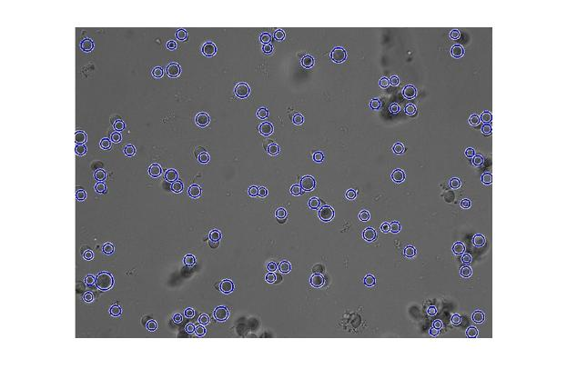](http://imageprocessingblog.com/wp-content/uploads/2013/07/Spores31.jpg)

We got a relatively good detection for the number of spores, finally we can count the number of circles.

length(centersNew)  
ans = 94

So, we counted 94 spores!

[Share](http://www.addtoany.com/share_save#url=http%3A%2F%2Fimageprocessingblog.com%2Fdetecting-and-counting-objects-with-circular-features%2F&title=Detecting%20and%20Counting%20Objects%20with%20Circular%20Features&description=How%20to%20detect%20circles%20using%20imfindcircles%20function%2C%20and%20how%20to%20remove%20overlapping%20circles.%20In%20order%20to%20automatically%20count%20fungi%20spores%2C%20which%20has%20various%20elliptical%20like%20shapes.)

[circles overlap](http://imageprocessingblog.com/tag/circles-overlap/), [count objects](http://imageprocessingblog.com/tag/count-objects/), [count spores](http://imageprocessingblog.com/tag/count-spores/), [detect ellipse](http://imageprocessingblog.com/tag/detect-ellipse/), [detect fungi](http://imageprocessingblog.com/tag/detect-fungi/), [detect mold spores](http://imageprocessingblog.com/tag/detect-mold-spores/), [detect objects](http://imageprocessingblog.com/tag/detect-objects/), [find circles](http://imageprocessingblog.com/tag/find-circles/), [imfindcircles](http://imageprocessingblog.com/tag/imfindcircles/)